

**Purpose**:

This guide is designed to help you change your email signature to one that was designed and approved by Encore Electric. Encore Electric’s Information Technology and Marketing teams have rolled out new email signatures to all email users. This is being undertaken in order to ensure continued correct and consistent communication standards as our company continues to add new members of the team.

The new signatures are part of an effort to maintain brand standards, especially as the Encore Electric logo is concerned. You may remember a change to the new logo during 2017, where the staff added a registered trademark symbol (®) to the logo and icon. That change, and this one, are both designed to reduce any remaining confusion regarding the Encore Electric name, logo and brand.

**Help**:

If you need help using this guide or you are running into trouble installing the new signature, please open a ticket by emailing [IT.Support@EncoreElectric.com](mailto:IT.Support@EncoreElectric.com).

**Example of a new signature**:

This is an example of the new signature. This is the one you should be installing on your iPad. If you cannot find this version of the signature, please email the help desk at [IT.Support@EncoreElectric.com](mailto:IT.Support@EncoreElectric.com).

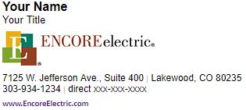

(Instructions for installation start on next page)

**Step 1:**

From your iPad, highlight the entire signature you would like to install on your iPad. You will find seven different versions of the signature below. You can do this by pressing and holding on a portion of the signature, then dragging the cursors until the entire signature you want is highlighted.

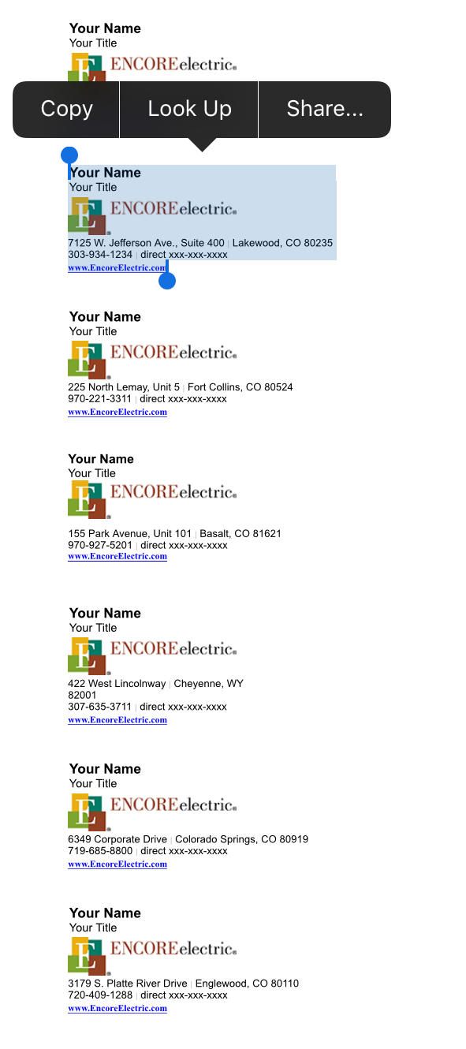

**(Copy and paste one of the signatures from below, or on the next page)**

|  |
| --- |
| **Your Name** Your Title |
|  |
| 77 Metcalf Road | Avon, CO 81620  970-949-9277 | direct xxx-xxx-xxxx |
| [**www.EncoreElectric.com**](http://www.EncoreElectric.com) |

|  |
| --- |
| **Your Name** Your Title |
|  |
| 7125 W. Jefferson Ave., Suite 400 | Lakewood, CO 80235  303-934-1234 | direct xxx-xxx-xxxx |
| [**www.EncoreElectric.com**](http://www.EncoreElectric.com) |

|  |
| --- |
| **Your Name** Your Title |
|  |
| 225 North Lemay, Unit 5 | Fort Collins, CO 80524  970-221-3311 | direct xxx-xxx-xxxx |
| [**www.EncoreElectric.com**](http://www.EncoreElectric.com) |

**Your Name**  
Your Title



155 Park Avenue, Unit 101 | Basalt, CO 81621   
970-927-5201 | direct xxx-xxx-xxxx  
[**www.EncoreElectric.com**](http://www.EncoreElectric.com)

|  |
| --- |
| **Your Name** Your Title |
|  |
| 422 West Lincolnway | Cheyenne, WY 82001  307-635-3711 | direct xxx-xxx-xxxx |
| [**www.EncoreElectric.com**](http://www.EncoreElectric.com) |

|  |
| --- |
| **Your Name** Your Title |
|  |
| 6349 Corporate Drive | Colorado Springs, CO 80919  719-685-8800 | direct xxx-xxx-xxxx |
| [**www.EncoreElectric.com**](http://www.EncoreElectric.com) |

|  |
| --- |
| **Your Name** Your Title |
|  |
| 3179 S. Platte River Drive | Englewood, CO 80110  720-409-1288 | direct xxx-xxx-xxxx |
| [**www.EncoreElectric.com**](http://www.EncoreElectric.com) |

**Step 2:**

Open your Boxer app from your home screen.

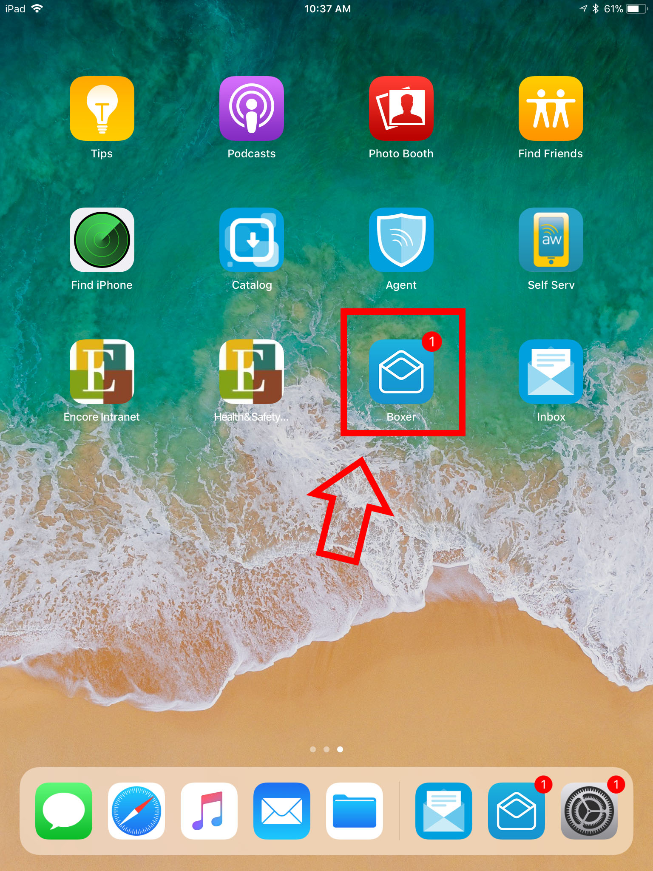

**Step 3:**

When the app loads, select “settings” on the bottom of the window.

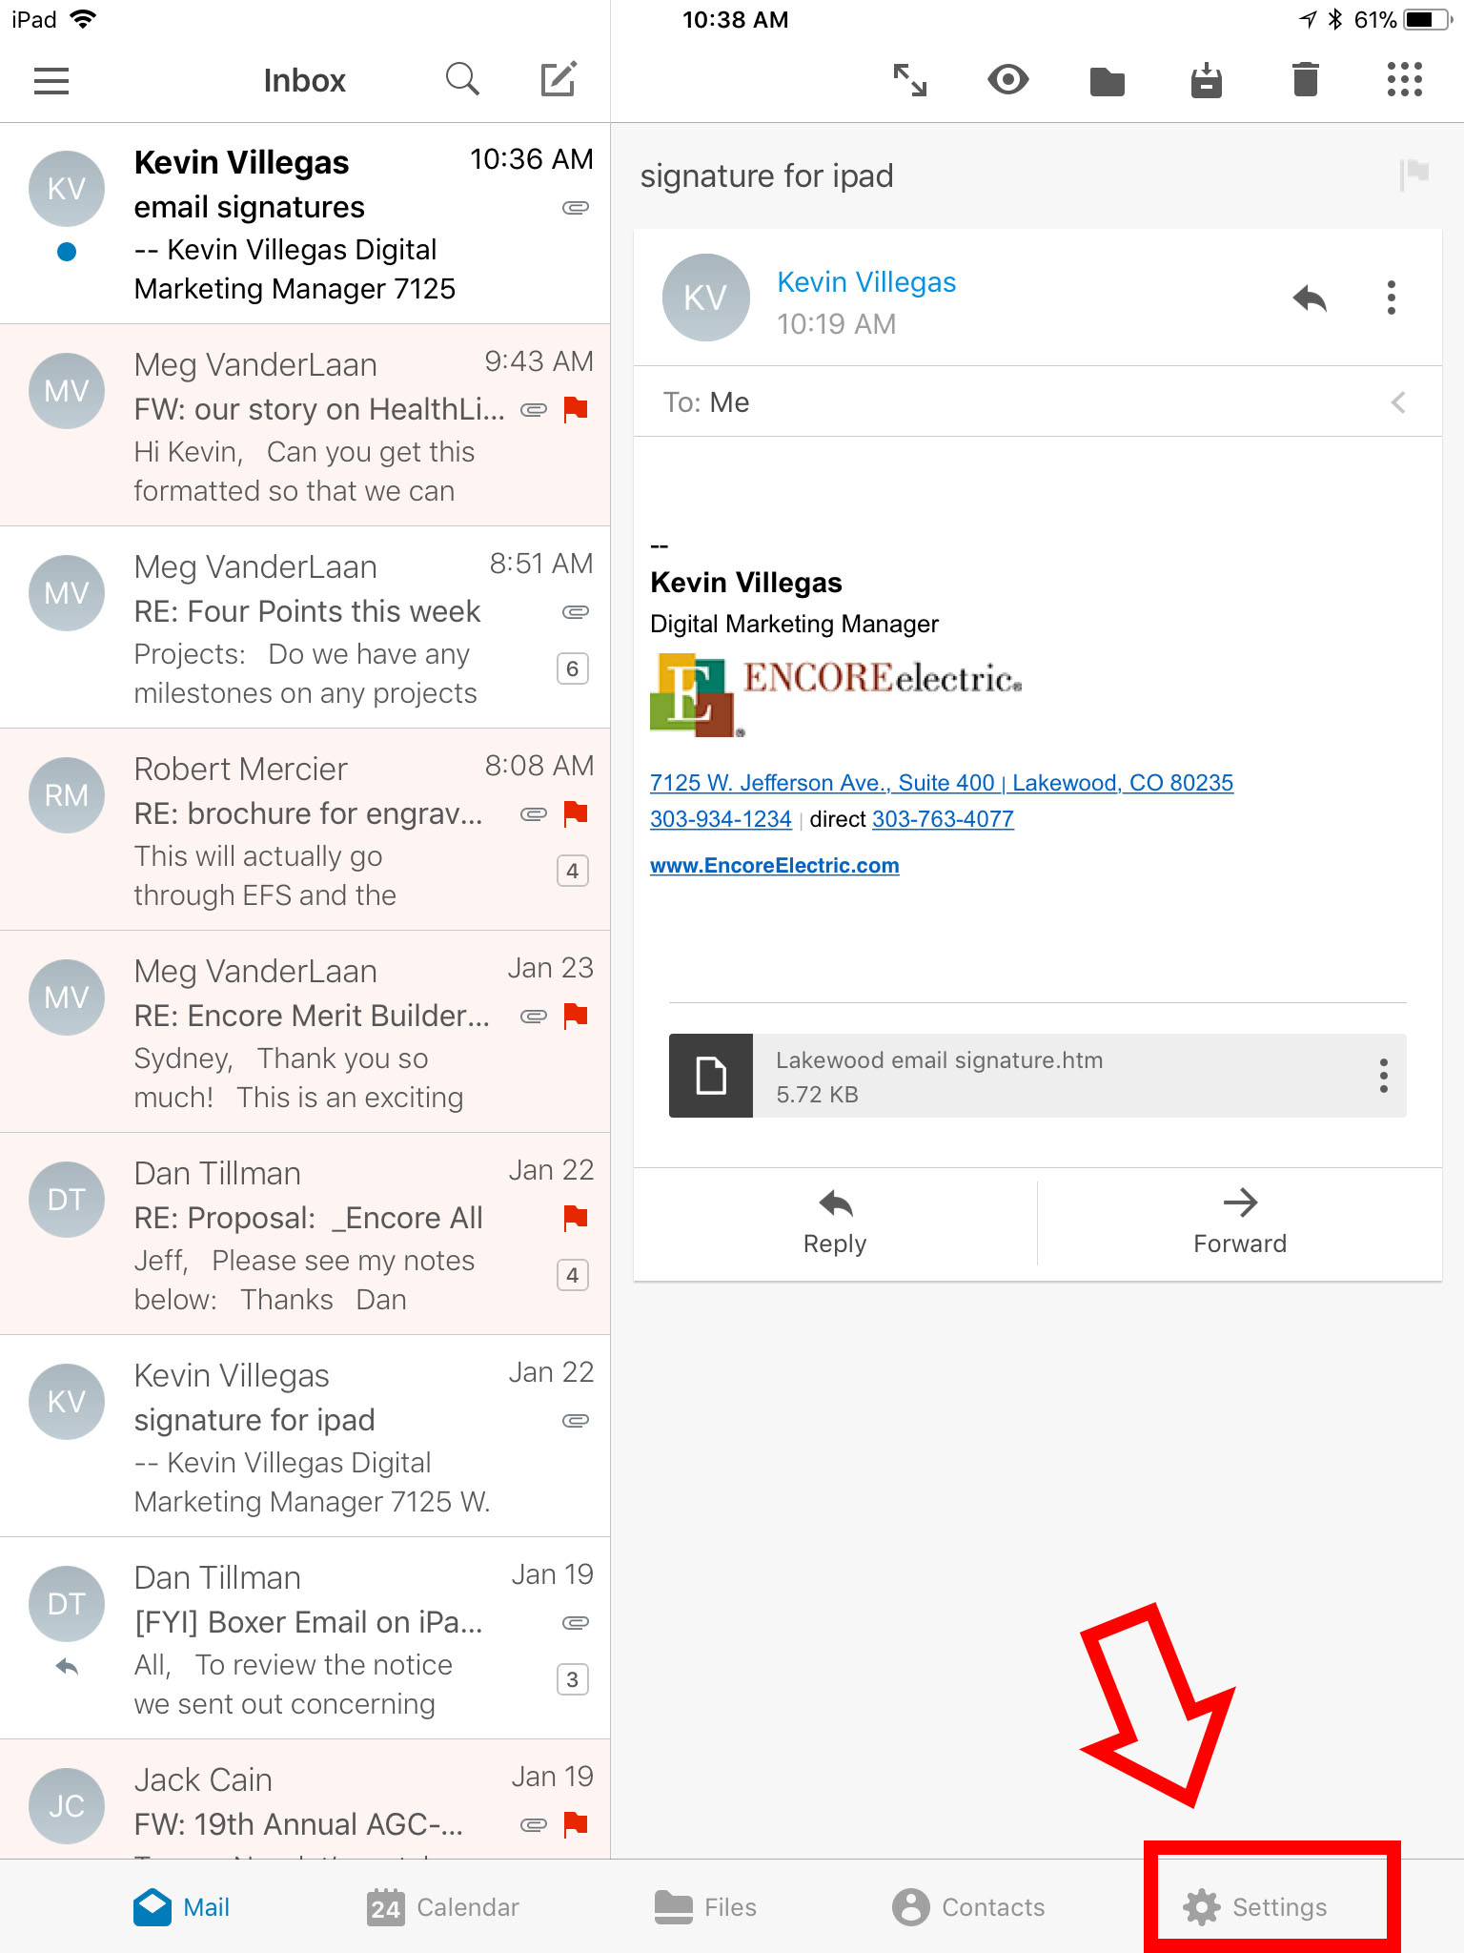

**Step 4:**

On the next screen, select “Encore Electric, Inc.”.

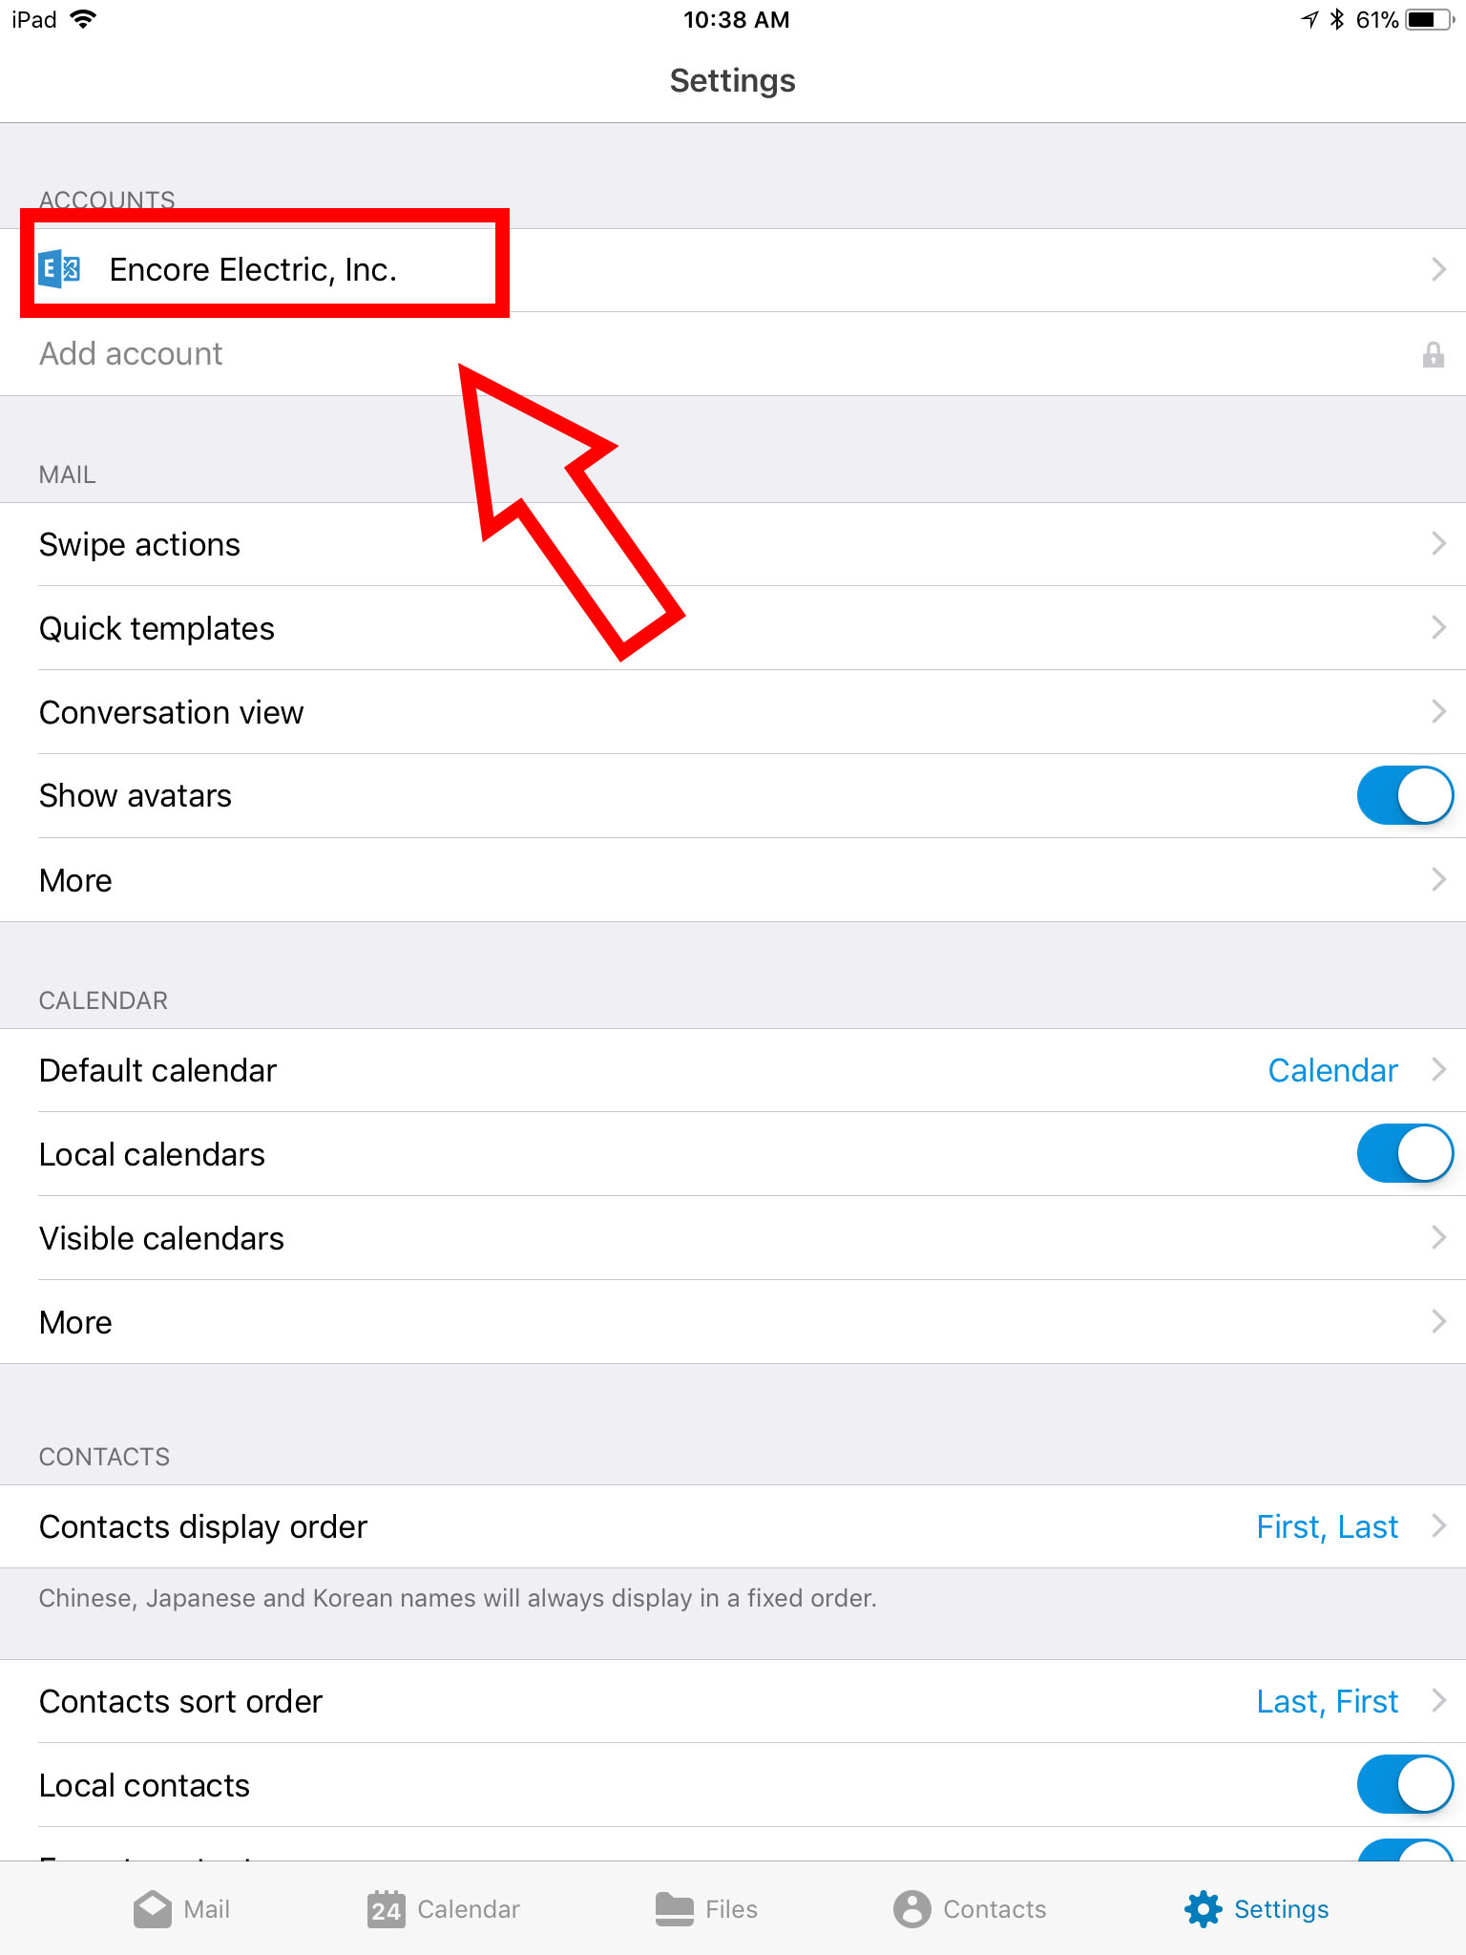

**Step 5:**

Select “Signature” from the left side of the window.

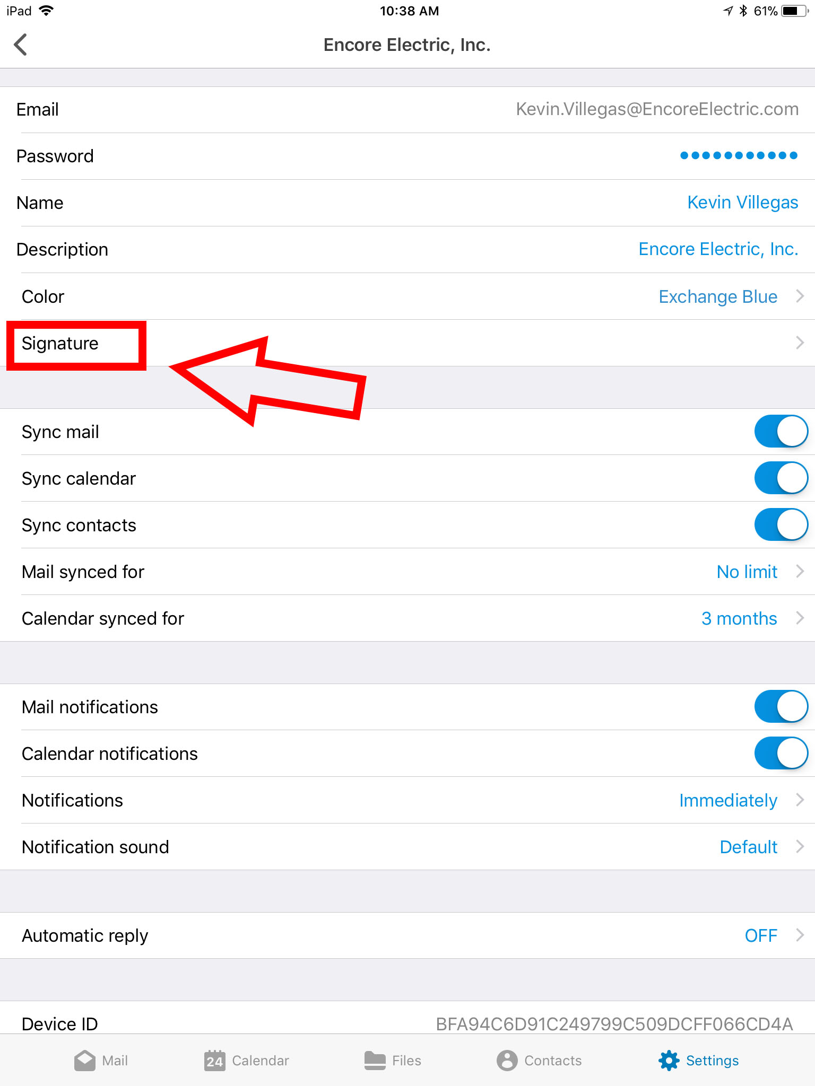

**Step 6:**

The signature editor opens. First, click the slider “HTML enabled” to enable pasting of the signature, then press in the top left corner of the editor box and click on paste.

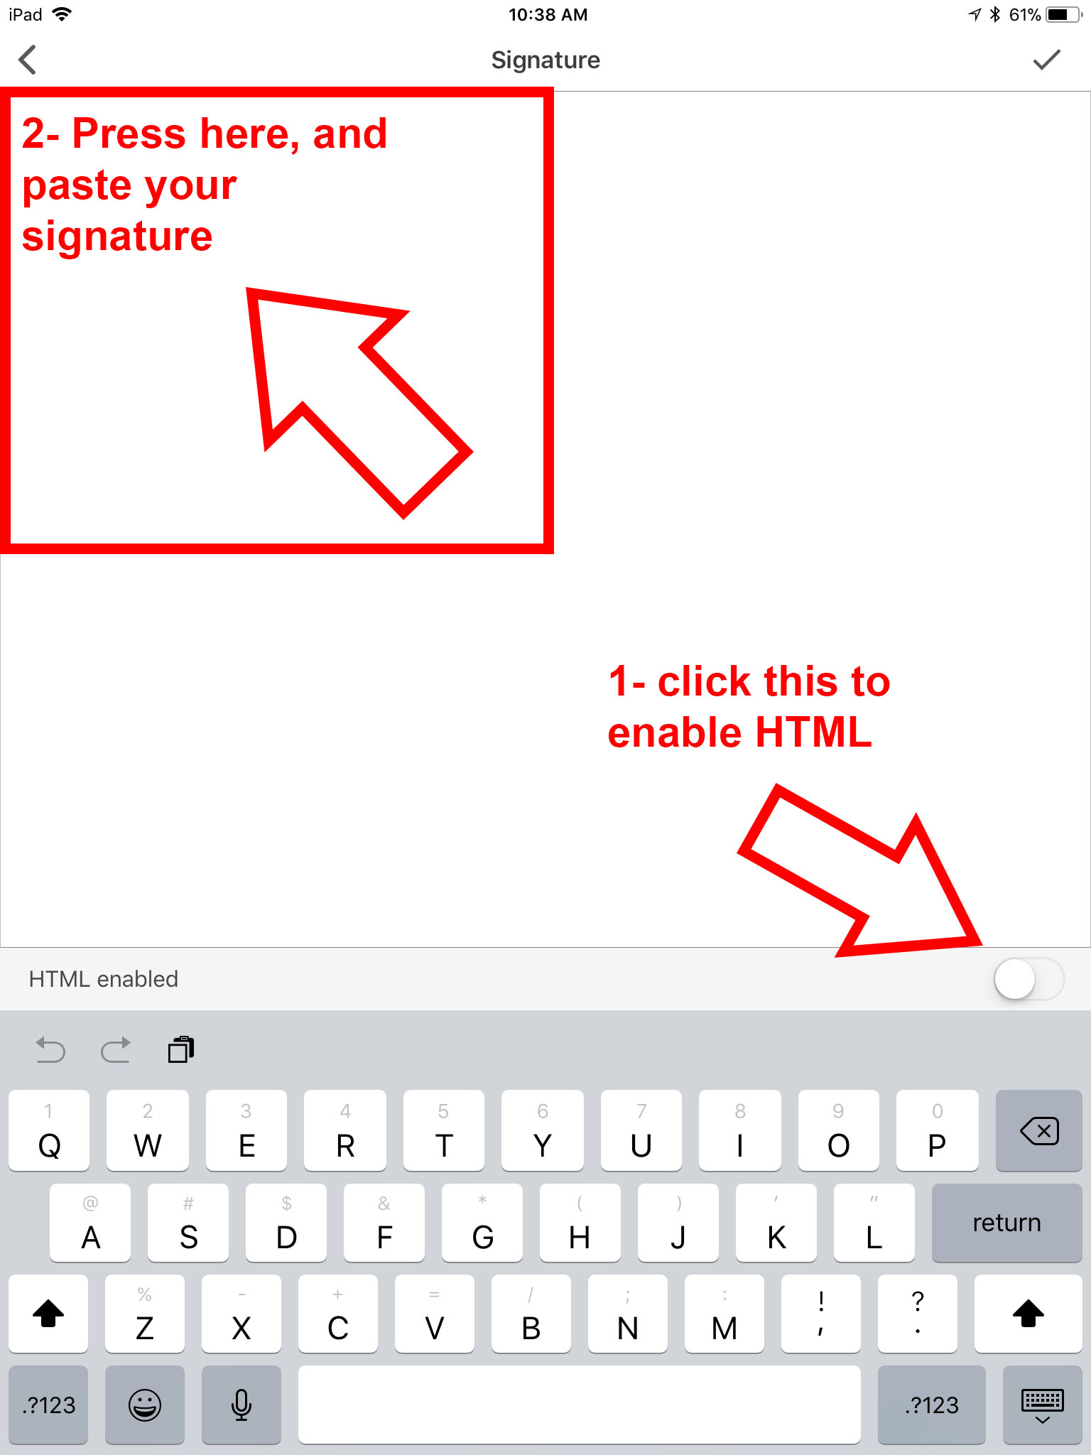

**Step 7:**

Edit the Name, Job Title and direct phone number in the email signature by selecting them and replacing them with your name, title and phone number. If you would like, you may add your mobile phone number on the same line as the other phone numbers. Do not change the font, weight or color of any of the text on the signature. If you have any designations or certifications that you would like to include in your email signature, feel free to put those next to your name (Example: **David Scott, SHRM**). Do not put them on a separate line. When you are done, click the checkmark in the top right corner of the screen.

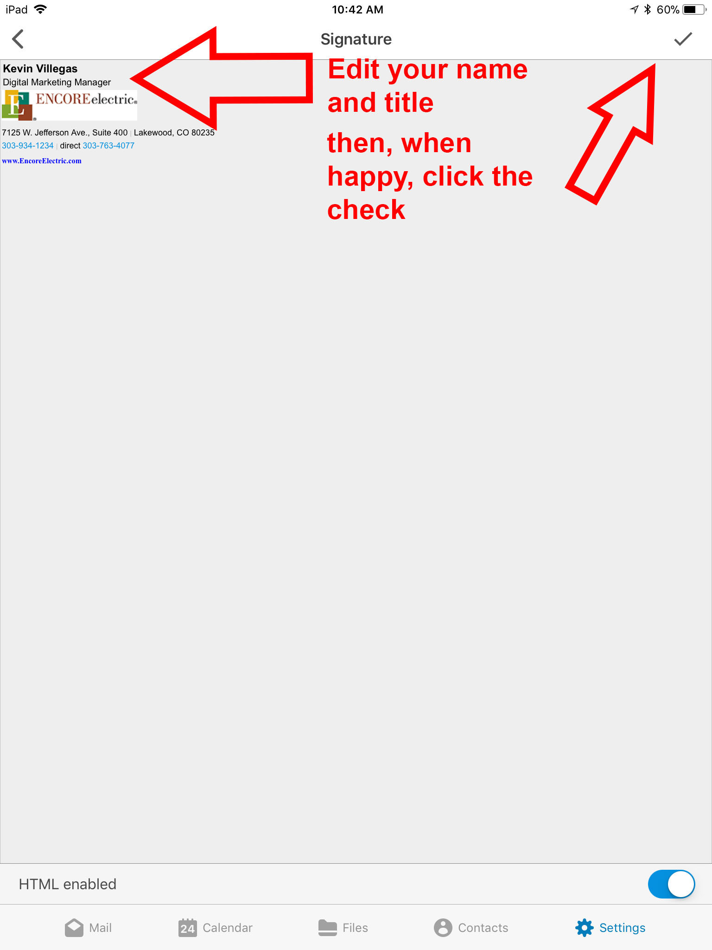

**Step 8:**

The next screen the opens is your inbox. Click on the “New Message” icon at the top of the inbox to preview your email signature.

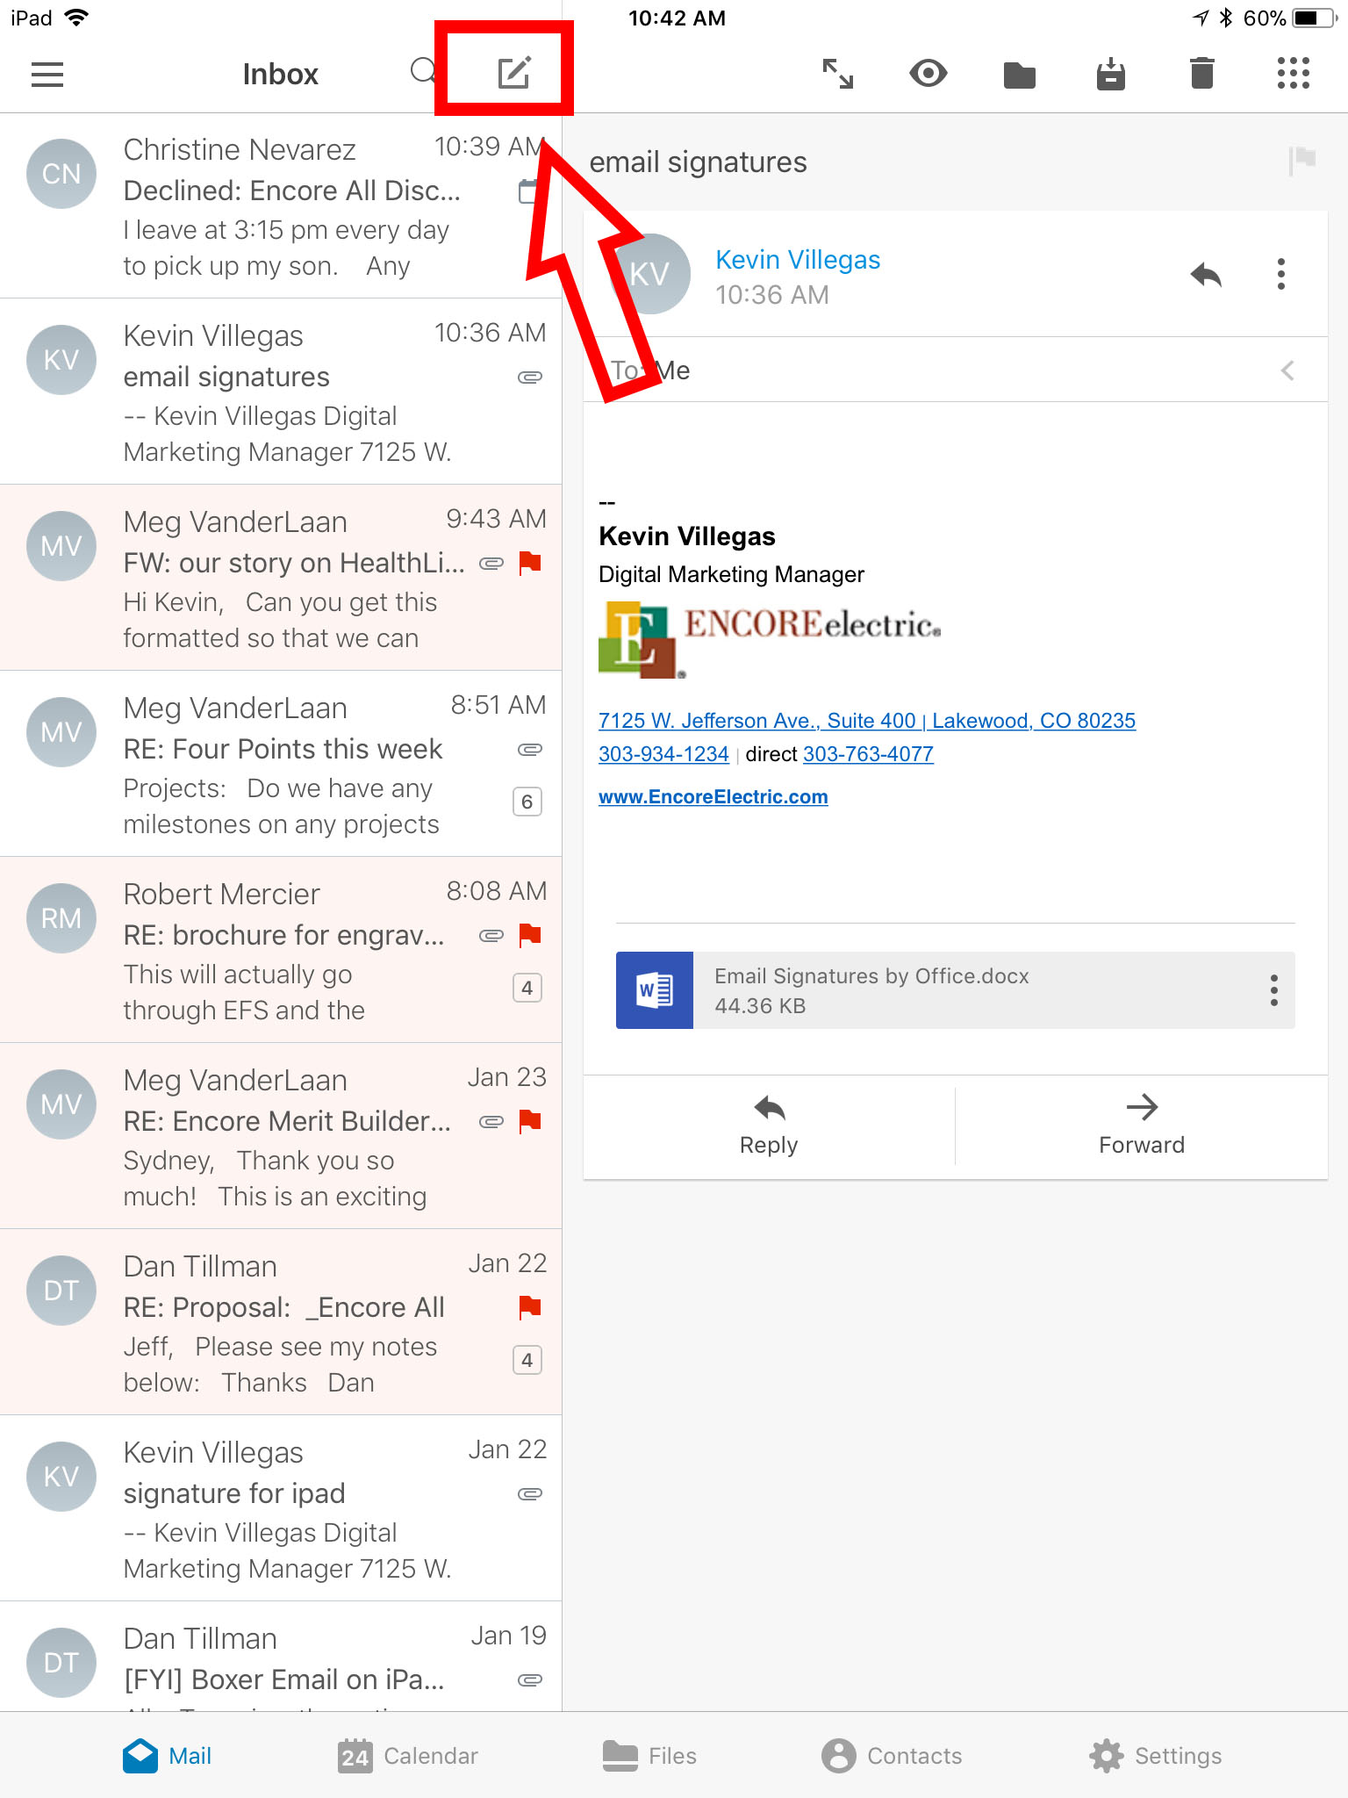

**Step 9:**

Ensure that you edited and saved your new signature correctly by opening a new email and checking to see your new signature is displaying correctly. Pat yourself on the back.

